Heritage University 02-19-24

Mathematics and Computer Science Dept. due: 02-25-24

Database II

Homework 4

*(PHP, MYSQL, XAMPP, MongoDB)*

*Part1*

1. **Consider** a database (mydb) that has messages (id,name,message, date) in the message table.

Data :

|  |  |  |
| --- | --- | --- |
| id | name | message |
| 1 | peter | hello all |
| 2 | paul | Hello |
| 3 | melissa | Bye |
| 4 | ann | Good morning |

The column “date” will be created while the records are inserted into the message table.

Please do the following:

1a.insert data with PHP script (insertmes.php) (or addmessage.php from hw4)

**CODE:**

<!—Question 1A insertmes.php -->

<!DOCTYPE html>

<html lang="en">

<head>

<meta charset="UTF-8">

<title>Insert Messages</title>

</head>

<body>

<?php

$errors = []; //intialize error array

//make connnect to the database

$dbc = @mysqli_connect("localhost", 'root', '', 'mydb') OR

die('Could not connect MySQL: ' . mysqli_connect_error() );

//if post is submitted

if ($_SERVER["REQUEST_METHOD"] == "POST"){

if (empty($_POST["name"])){ //if name was empty

$errors = "name is required";

}

if (empty($_POST["message"])){ //if message was empty

$errors = "message is required";

}

if (empty($errors)){

$stmt = mysqli_prepare($dbc, "INSERT INTO messages (id, name, message, date) VALUES (DEFAULT, ?, ?, NOW())");

//bind parameters

mysqli_stmt_bind_param($stmt, "ss", $name, $message);

//Set parameters and execute

$name = $_POST['name'];

$message = $_POST['message'];

//execute statement

if (mysqli_stmt_execute($stmt)) {

echo "New record inserted successfully</br>";

} else {

echo "Error: " . mysqli_error($dbc);

}

// Close statement

mysqli_stmt_close($stmt);

}

}

//close connecition

mysqli_close($dbc);

// Display errors from NULL values

if (!empty($errors)) {

echo "<h3>Error List:</h3>";

echo "<ul>";

foreach ($errors as $error) {

echo "<li>$error</li>";

}

echo "</ul>";

}

?>

<h1>Submit Messages</h1>

<form action="insertmes.php" method="post">

<p><label for="name">Name:</label><br>

<input type="text" id="name" name="name"></p>

<p><label for="message">Message:</label><br>

<input type="text" id="message" name="message"></p>

<input type="submit" value="Submit">

</form>

</body>

</html>

**OUTPUT:**

1b.print the messages (printmes.php)

**CODE:**

<!-- Question 1B printmes.php -->

<!DOCTYPE html>

<html lang="en">

<head>

<meta charset="UTF-8">

<title>Insert Messages</title>

</head>

<body>

<?php

//header of page

echo "<h1 align=\"center\">Messages Submitted</h1>";

//make connnect to the database

$dbc = @mysqli_connect("localhost", 'root', '', 'mydb') OR

die('Could not connect MySQL: ' . mysqli_connect_error() );

//make query

$query = "SELECT * FROM messages";

//execute query and get results

$result = mysqli_query($dbc, $query);

$row_count = mysqli_num_rows($result);

if ($row_count > 0){

// creates table header

echo '<table align="center" width=”60%” cellpadding="10">

<thead>

<tr align=center>

<th align=”center”>name</th>

<th align=”center”>message</th>

<th align=”center”>date</th>

</tr>

</thead>

<tbody>';

//fetch and display all data in tables

while ($row = mysqli_fetch_assoc($result)){

echo '<tr><td align="center">' . $row['name'] .

'</td><td align="center">' . $row['message'] .

'</td><td align="center">' . $row['date'] .

'</td></tr>';

}

//close the table

echo '</tbody><table>';

mysqli_free_result($result); //free up space

} else if ($result) { //empty result

echo '<p align="center">No Results</p>';

mysqli_free_result($result);

} else { //it it failed

//message to user

echo '<p class="error"><strong>Query failed.</strong></p>';

//debug message

echo '<p>' . mysqli_error($dbc) . '<br><br>Query: ' . $q . '</p>';

}

mysqli_close($dbc);

?>

</body>

</html>

**OUTPUT:**

1c. print the messages in descent date order.(printordermes.php)

**CODE:**

<!-- Question 1C printordermes.php -->

<!DOCTYPE html>

<html lang="en">

<head>

<meta charset="UTF-8">

<title>Insert Messages</title>

</style>

</head>

<body>

<?php

//header of page

echo "<h1 align=\"center\">Messages Submitted in Descending Order</h1>";

//make connnect to the database

$dbc = @mysqli_connect("localhost", 'root', '', 'mydb') OR

die('Could not connect MySQL: ' . mysqli_connect_error() );

//make query

$query = "SELECT * FROM messages ORDER BY date DESC";

//execute query and get results

$result = mysqli_query($dbc, $query);

if ($result){

// creates table header

echo '<table align="center" width=”60%” cellpadding="10">

<thead>

<tr align=center>

<th align=”center”>name</th>

<th align=”center”>message</th>

<th align=”center”>date</th>

</tr>

</thead>

<tbody>';

//fetch and display all data in tables

while ($row = mysqli_fetch_assoc($result)){

echo '<tr><<td align="center">' . $row['name'] .

'</td><td align="center">' . $row['message'] .

'</td><td align="center">' . $row['date'] .

'</td></tr>';

}

//close the table

echo '</tbody><table>';

mysqli_free_result($result); //free up space

} else if ($result) { //empty result

echo '<p align="center">No Results</p>';

mysqli_free_result($result);

} else { //it it failed

//message to user

echo '<p class="error"><strong>Query failed.</strong></p>';

//debug message

echo '<p>' . mysqli_error($dbc) . '<br><br>Query: ' . $q . '</p>';

}

mysqli_close($dbc);

?>

</body>

</html>

**OUTPUT:**

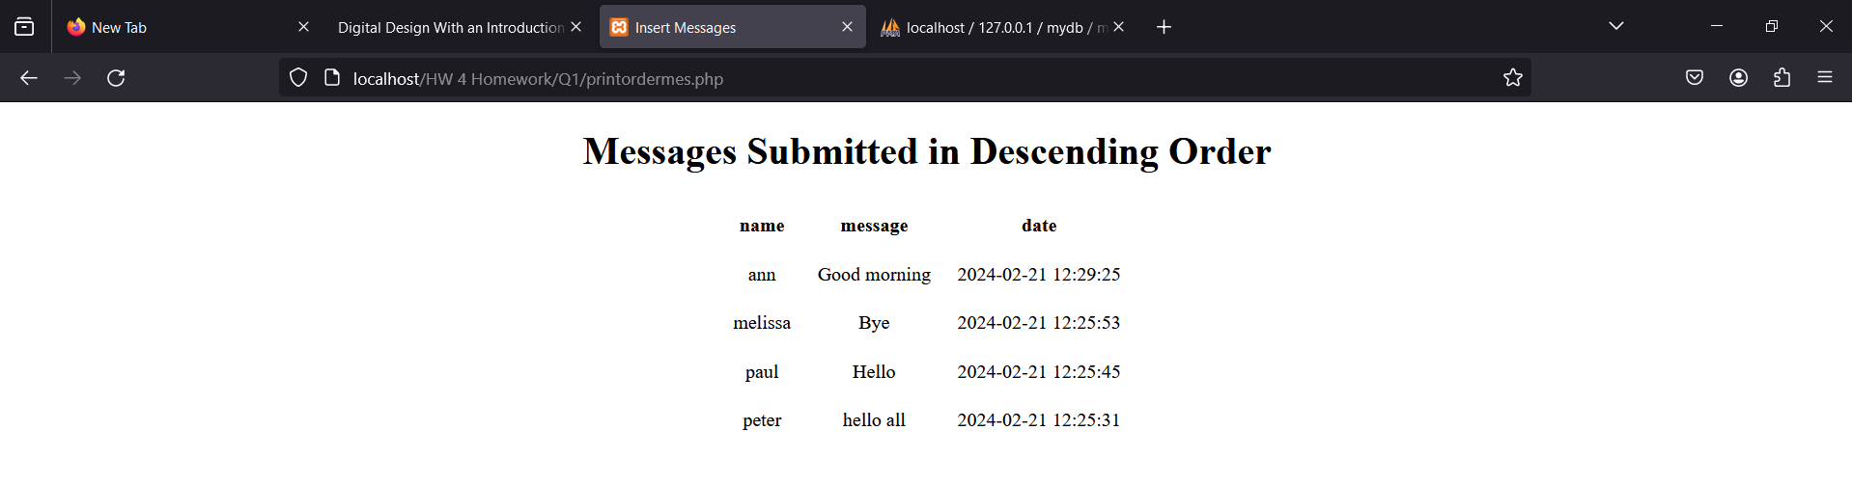

1d. find the number of records (nummes.php) with messages in descent date order

**CODE:**

<!-- Question 1C printordermes.php -->

<!DOCTYPE html>

<html lang="en">

<head>

<meta charset="UTF-8">

<title>Insert Messages</title>

</style>

</head>

<body>

<?php

//header of page

echo "<h1 align=\"center\">Messages Submitted in Descending Order</h1>";

//make connnect to the database

$dbc = @mysqli_connect("localhost", 'root', '', 'mydb') OR

die('Could not connect MySQL: ' . mysqli_connect_error() );

//make query

$query = "SELECT * FROM messages ORDER BY date DESC";

//execute query and get results

$result = mysqli_query($dbc, $query);

if ($result){

// creates table header

echo '<table align="center" width=”60%” cellpadding="10">

<thead>

<tr align=center>

<th align=”center”>name</th>

<th align=”center”>message</th>

<th align=”center”>date</th>

</tr>

</thead>

<tbody>';

//fetch and display all data in tables

while ($row = mysqli_fetch_assoc($result)){

echo '<tr><<td align="center">' . $row['name'] .

'</td><td align="center">' . $row['message'] .

'</td><td align="center">' . $row['date'] .

'</td></tr>';

}

//close the table

echo '</tbody><table>';

mysqli_free_result($result); //free up space

} else if ($result) { //empty result

echo '<p align="center">No Results</p>';

mysqli_free_result($result);

} else { //it it failed

//message to user

echo '<p class="error"><strong>Query failed.</strong></p>';

//debug message

echo '<p>' . mysqli_error($dbc) . '<br><br>Query: ' . $q . '</p>';

}

mysqli_close($dbc);

?>

</body>

</html>

**OUTPUT:**

1e.update the “Bye” message with “Hi”(updmess.php)

**CODE:**

<!--1E updmess.php -->

<!--accessed from nummes.php-->

<!DOCTYPE HTML>

<html lang="en">

<head>

<meta charset="UTF-8">

<title>Update Message</title>

</head>

<body>

<?php

//insert header

echo '<h1>Update a Message</h1>';

// Check for a valid user ID, through GET or POST:

if ((isset($_GET['id'])) && (is_numeric($_GET['id']))) {

$id = $_GET['id']; //accessed through href link

} else if ((isset($_POST['id'])) && (is_numeric($_POST['id']))) {

$id = $_POST['id']; //if id is gained from form submission

} else {

echo '<p class="error">This page has been accessed in error.</p>';

exit();

}

$dbc = @mysqli_connect('localhost', 'root', '', 'mydb');

// Check if the form has been sumbitted:

if ($_SERVER['REQUEST_METHOD'] == 'POST') {

$error = ""; //intialize error string

// Check for new message has input:

if (empty($_POST['new_message'])) {

$error = 'Please insert a new message';

} else {

$new_message = mysqli_real_escape_string($dbc, trim($_POST['new_message']));

}

if (empty($errors)) { // if there are no errors

// Make the query:

$query = "UPDATE messages SET message='$new_message'

WHERE id=$id";

$result = @mysqli_query($dbc, $query);

if (mysqli_affected_rows($dbc) == 1) {

//print a message:

echo '<p>The message has been updated.</p>';

} else {

echo '<p class="error">The message could not be due updated due to a system error.

We apologize for any inconvenience.</p>'; // Public message.

echo '<p>' . mysqli_error($dbc) . '<br>Query: ' . $query . '</p>';

// Debugging message

}

} else { //Report the errors.

echo '<p class="error">The following error occurred:<br>'

. $error . '</p><p>Please try again.</p>';

}

}

//Retrieve the id's message

$query = "SELECT message FROM messages WHERE id=$id";

$result = @mysqli_query($dbc, $query);

if (mysqli_num_rows($result) == 1) {

//Get the users's information:

$row = mysqli_fetch_assoc($result);

// Create the form:

echo '<form action="updmess.php" method="post">

<p>Old Message: &nbsp&nbsp'. $row['message'] . '</p>

<p>New Message: <input type="text" name="new_message" size="15"

maxlength="15"></p>

<p><input type="submit" name="submit" value="Submit"></p>

<input type="hidden" name="id" value="' . $id .'"></form>';

} else {

echo '<p class="error">This page has been accessed in error.</p>';

}

//gives you link to return to nummes.php

echo '<p><a href="nummes.php">Return to nummes.php</a></p>';

mysqli_close($dbc);

?>

</body>

</html>

**OUTPUT:**

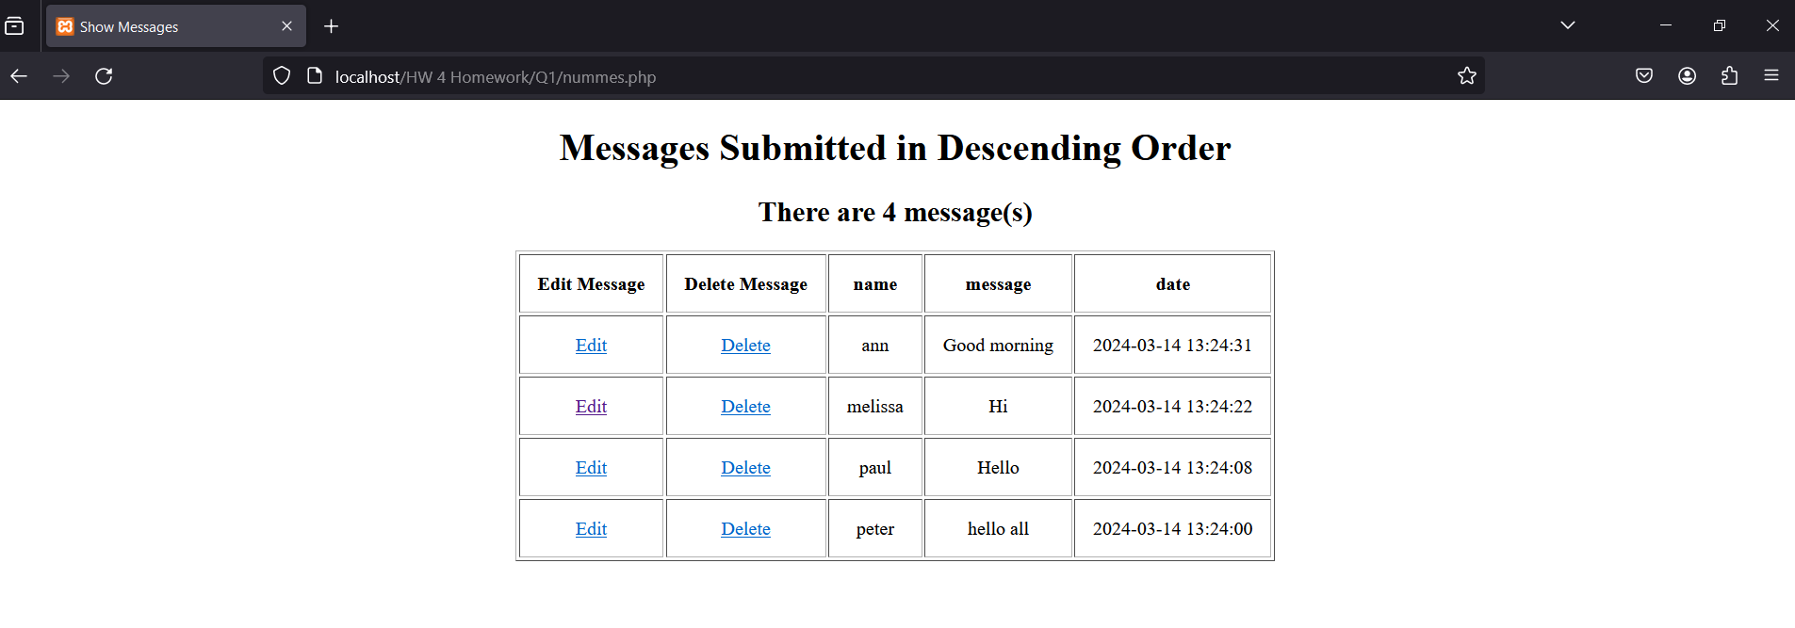

1f. delete the updated record (delmess.php

**CODE:**

<!--1D delmess.php -->

<!--accessed from nummes.php-->

<!DOCTYPE HTML>

<html lang="en">

<head>

<meta charset="UTF-8">

<title>Delete Message</title>

</head>

<body>

<?php

//insert header

echo '<h1>Delete a Message</h1>';

// Check for a valid user ID, through GET or POST:

if ((isset($_GET['id'])) && (is_numeric($_GET['id']))) {

$id = $_GET['id']; //accessed through href link

} else if ((isset($_POST['id'])) && (is_numeric($_POST['id']))) {

$id = $_POST['id']; //retrieved from form submission

} else {

echo '<p class="error">This page has been accessed in error.</p>';

exit();

}

//make connection to database

$dbc = @mysqli_connect('localhost', 'root', '', 'mydb') OR

die('Could not connect MySQL: ' . mysqli_connect_error() );

// Check if the form has been sumbitted:

if ($_SERVER['REQUEST_METHOD'] == 'POST') {

if ($_POST['selection'] == 'Yes') { // Delete the record.

// Make the query:

$query = "DELETE FROM messages WHERE id=$id";

$result = @mysqli_query($dbc, $query);

if (mysqli_affected_rows($dbc) == 1) { // if it ran OK

//print a message:

echo '<p>The message has been deleted.</p>';

} else { // If the query did not run OK.

echo '<p class="error">The user could not be deleted due to a systme error.</p>';

//public message

echo '<p>' . mysqli_error($dbc) . '<br>Query: ' . $query . '</p>'; //debugging for me

}

}

} else {

// Retrieve the the message

$query = "SELECT message FROM messages WHERE id=$id";

$result = @mysqli_query($dbc, $query);

if (mysqli_num_rows($result) == 1) { //retrieved the message

$row = mysqli_fetch_row($result);

//Display the message that will be deleted

echo "<h3>Message: $row[0]</h3>

Are you sure you want to delete this message?";

// Create the form:

echo '<form action="delmess.php" method="post">

<input type="radio" name="selection" value="Yes">Yes

<input type="radio" name="selection" value="No" checked="checked">No

<input type="submit" name="submit" value="Submit">

<input type="hidden" name="id" value="' . $id . '">

</form>';

} else { //if query somehow has more

echo '<p class="errror">This page has been accesedd in error.</p>';

}

}

//returns you to nummes.php

echo '<p><a href="nummes.php">Return to nummes.php</a></p>';

mysqli_close($dbc);

?>

</body>

</html>

**OUTPUT:**

Hint: Give screenshots where it is needed. First give the PHP script and next put the screenshots. For the update and delete operations first the record will appear giving the id (in URL) and secondly the execution

*Part 2*

1. Create a php file (shoespr.php) that can create database( shoesdb) with table shoes(type,color, size) using phpMyAdmin. For shoes table use id as autoincrement primary key. (use MySQLi Procedural method)

shoes

|  |  |  |
| --- | --- | --- |
| type | color | size |
| A | blue | 10 |
| A | black | 12 |
| B | green | 9 |
| C | black | 9 |

*Output:* The shoespr.php will display the data with format as the above shoes table.

Please provide with the program the necessary screenshot (i.e. create the table with data) from XAMPP screens for all the questions.

**CODE:**

<!-- PART 2: Q1 shoespr.php -->

<!DOCTYPE HTML>

<html lang="en">

<head>

<meta charset="UTF-8">

<title>SHOES</title>

</head>

<body>

<?php

//creates header

echo "<h1 align=\"center\">DATABASE: shoesdb<br>TABLE: shoes</h1>";

//connect to myPHPadmin SQL Server

$dbc = @mysqli_connect('localhost', 'root', '');

//drop database if it exists

$query = "DROP DATABASE IF EXISTS shoesdb";

if (!mysqli_query($dbc, $query))

echo "Error in dropping the database: " . mysqli_error($dbc);

//query to create DATABASE shoedb

$query = "CREATE DATABASE shoesdb";

if (!mysqli_query($dbc, $query))

echo "Error creating database: " . mysqli_error($dbc);

//select shoedb to use

$query = "USE shoesdb";

if (!mysqli_query($dbc, $query))

echo "Error selecting database: " . mysqli_error($dbc);

//query to create TABLE shoes

$query = "CREATE TABLE IF NOT EXISTS shoes(

id INT AUTO_INCREMENT,

type CHAR(1) NOT NULL,

color VARCHAR(10) NOT NULL,

size INT(2) NOT NULL,

PRIMARY KEY (id)

)";

if (!mysqli_query($dbc, $query))

echo "Error creating table: " . mysqli_error($dbc);

//query to add VALUES to tables

$query = "INSERT INTO shoes VALUES

(DEFAULT, 'A', 'blue', 10),

(DEFAULT, 'A', 'black', 12),

(DEFAULT, 'B', 'green', 9),

(DEFAULT, 'C', 'black', 9)

";

if (!mysqli_query($dbc, $query))

echo "Error inserting data into table: " . mysqli_error($dbc);

// get all values from table to display

$query = "SELECT * FROM shoes";

//run the query

$result = mysqli_query($dbc, $query);

//count the number of returned rows

$num = mysqli_num_rows($result);

if ($num > 0){

//create table header

echo '<table align="center" width="50%" border="solid" cellpadding="10">

<thead>

<tr align="center">

<th align="center">id</th>

<th aligh="center">type</th>

<th align=”center”>color</th>

<th align=”center”>size</th>

</tr>

</thead>

<tbody>';

//adds all values to table

while ($row = mysqli_fetch_assoc($result))

echo '<tr><td align="center">' . $row['id'] . '</td>

<td align="center">' . $row['type'] . '</td>

<td align="center">' . $row['color'] . '</td>

<td align="center">' . $row['size'] . '</td></tr>';

echo '</tbody></table>';

mysqli_free_result($result); //free up space

} elseif ($result) { //empty query result

echo "Query returned zero results";

mysqli_free_result($result); //free up space

} else { //error with query

echo "Error retrieving query result: " . mysqli_error($dbc);

}

mysqli_close($dbc);

?>

</body>

</html>

**OUTPUT:**

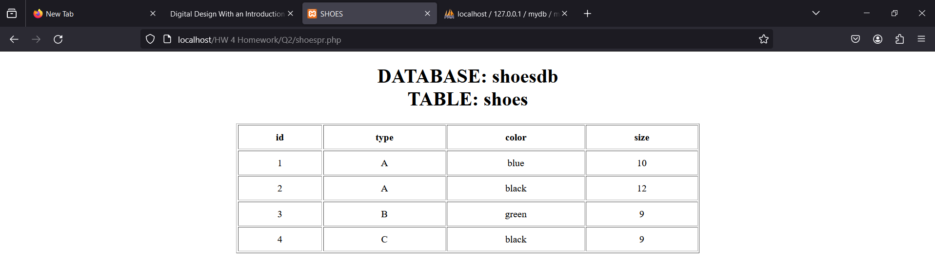

*Part 3*

3.Please prepare the following: (MongoDB)

3a. create database: product_sales and collection:sales

**CODE:**

test> use product_sales

product_sales> db.createCollection(“sales”)

**OUTPUT:**

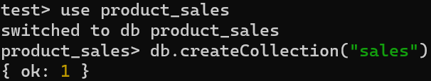

3b. insert data:

|  |  |  |  |  |  |  |  |  |
| --- | --- | --- | --- | --- | --- | --- | --- | --- |
| orderid | orderdate | quantity | salesamt | profit | customername | productcateg | productname | productid |
| 1 | 25/03/2012 | 20 | 200 | 150 | peter | fruits | apple | 1 |
| 2 | 26/03/2012 | 30 | 250 | 30 | ann | bakery | bread | 3 |
| 3 | 27/03/2012 | 30 | 200 | 80 | paul | deli | ham | 4 |
| 4 | 28/03/2012 | 40 | 220 | 20 | mary | fruit | orange | 4 |

**CODE:**

product_sales>db.sales.insertMany([{orderid : 1,orderdate : new Date("2012-03-25"), quantity : 20, salesamt : 200, profit : 150, customername : "peter", productcateg : "fruits", productname : "apple", productid : 1}, { orderid : 2, orderdate : new Date("2012-03-26"), quantity : 30, salesamt : 250, profit : 30, customername : "ann", productcateg : "bakery", productname : "bread", productid : 3},{ orderid : 3, orderdate : new Date("2012-03-27"), quantity : 30, salesamt : 200, profit : 80, customername : "paul", productcateg : "deli", productname : "ham", productid : 4},{ orderid : 4, orderdate : new Date("2012-03-28"), quantity : 40, salesamt : 220, profit : 20, customername : "mary", productcateg : "fruit", productname : "orange", productid : 4}])

**OUTPUT:**

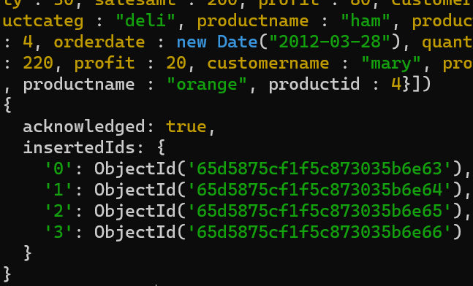

3c. provide query that show all data in sales

**CODE:**

product_sales>db.sales.find()

**OUTPUT:**

3d. prepare the code that show the data in a clearer way.

**CODE:**

product_sales>db.sales.find().pretty()

**OUTPUT:**

3e. find the document with customer name “paul”

**CODE:**

product_sales> db.sales.find({customername:'paul'})

**OUTPUT:**

3f. change the productcateg from "fruit" to "fruits" and display the data in a clearer way.

**CODE:**

product_sales>db.sales.updateOne({"productcateg":"fruit"},{$set:{"productcateg" : "fruits"}})

product_sales>db.sales.find().pretty()

**OUTPUT:**

3d. display in JSON the data that has fruits in productcateg.(use cursor)

**CODE:**

product_sales> var cursor = db.sales.find()

product_sales> cursor.forEach(function(doc) { printjson(doc); });

**OUTPUT:**

3e. using aggregation find the data that have salesamt greater or equal to 200

**CODE:**

product_sales> db.sales.aggregate( [ { $match: { salesamt: { $gte: 200} } ] )

**OUTPUT:**

3f. sort the data in increasing salesamt

**CODE:**

product_sales>db.sales.find().sort({salesamt : 1})

**OUTPUT:**

3g. find the smallest and the highest values of amounts for each product category and product name. (use aggregate)

**CODE:**

product_sales>db.sales.aggregate([{$facet: { ProductCategory: [ {$group: { _id:'$productcateg', minQuantity: {$min:'$quantity'}, maxQuantity: {$max : '$quantity'}, minSalesAmt : {$min: '$salesamt'}, maxSalesAmt: {$max:'$salesamt'}, minProfit: {$min:'$profit'}, maxProfit: {$max:'$profit'} }}], ProductName: [{ $group: { _id: '$productname', minQuantity: {$min: '$quantity'}, maxQuantity: {$max: '$quantity'}, minSalesAmt: {$min: '$salesamt'}, maxSalesAmt: {$max: '$salesamt'}, minProfit: {$min: '$profit'}, maxProfit: {$max: '$profit'}}}]}}])

**OUTPUT:**

3h. find for the product category:"fruits" a.the number of the records , b. the records , c. the summation of the amount (use aggregate)

3hA. **CODE:**

product_sales> db.sales.count({productcateg:"fruits"})

**OUTPUT:**



3hB. **CODE:**

product_sales> db.sales.find({productcateg:"fruits"})

**OUTPUT:**

3hC. **CODE:**

product_sales> product_sales> db.sales.aggregate([{$match: {productcateg:"fruits"}}, {$group: {_id : null, sumOfFruitSales: {$sum: '$salesamt' }}}, {$project: {_id:0, sumOfFruitSales:1}}])

**OUTPUT:**

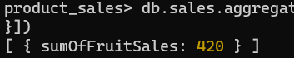

*Part 4*

Consider the case of car processing with the following three tables using XAMPP (phpMyAdmin):

car

|  |  |  |
| --- | --- | --- |
| id | license_plate | color |
| 1 | 578456 | blue |
| 2 | 578866 | blue |
| 3 | 578956 | white |
| 4 | 598456 | black |
| 5 | 679997 | black |

make

|  |  |
| --- | --- |
| make_id | make_name |
| 1 | volvo |
| 2 | bmw |
| 3 | mercedes |
| 4 | ford |
| 5 | honda |

owner

|  |  |  |  |
| --- | --- | --- | --- |
| id | owner_name | car_plate | car_make |
| 1 | peter | 1 | 2 |
| 2 | paul | 3 | 1 |
| 3 | ann | 4 | 4 |
| 4 | mary | 2 | 3 |

Please prepare the following:

4a.create database (carsdb) with the three tables : car,make,owner

4b. insert data into the tables as the above information

**CODE:**

<!-- PART 4: A & B carpr.php -->

<!DOCTYPE HTML>

<html lang="en">

<head>

<meta charset="UTF-8">

<title>carsdb</title>

<style>

table {

border-collapse: collapse;

border: 1px solid gray;

width: 50%;

float: center;

margin: 10px;

}

</style>

</head>

<body>

<?php

//connect to myPHPadmin SQL Server

$dbc = @mysqli_connect('localhost', 'root', '');

//drop database if it exists

$query = "DROP DATABASE IF EXISTS carsdb";

if (!mysqli_query($dbc, $query))

echo "Error in dropping the database: " . mysqli_error($dbc);

//query to create DATABASE cardb

$query = "CREATE DATABASE carsdb";

if (!mysqli_query($dbc, $query))

echo "Error creating database: " . mysqli_error($dbc);

//select cardb to use

$query = "USE carsdb";

if (!mysqli_query($dbc, $query))

echo "Error selecting database: " . mysqli_error($dbc);

//query to create TABLE car

$query = "CREATE TABLE IF NOT EXISTS car(

id INT AUTO_INCREMENT,

license_plate VARCHAR(6) NOT NULL,

color VARCHAR(10) NOT NULL,

PRIMARY KEY (id)

)";

if (!mysqli_query($dbc, $query))

echo "Error creating car table: " . mysqli_error($dbc);

//query to add VALUES to car TABLE

$query = "INSERT INTO car VALUES

(DEFAULT, '578456', 'blue'),

(DEFAULT, '578866', 'blue'),

(DEFAULT, '578956', 'white'),

(DEFAULT, '598456', 'black'),

(DEFAULT, '679997', 'black')";

if (!mysqli_query($dbc, $query))

echo "Error inserting data into car table: " . mysqli_error($dbc);

//query to create make TABLE

$query = "CREATE TABLE IF NOT EXISTS make(

make_id INT AUTO_INCREMENT,

make_name VARCHAR(20) NOT NULL,

PRIMARY KEY (make_id)

)";

if (!mysqli_query($dbc, $query))

echo "Error creating make table: " . mysqli_error($dbc);

//query to add VALUES to make table

$query = "INSERT INTO make VALUES

(DEFAULT, 'volvo'),

(DEFAULT, 'bmw'),

(DEFAULT, 'mercedes'),

(DEFAULT, 'ford'),

(DEFAULT, 'honda')";

if (!mysqli_query($dbc, $query))

echo "Error inserting data into make table: " . mysqli_error($dbc);

//query to create owner TABLE

$query = "CREATE TABLE IF NOT EXISTS owner(

id INT AUTO_INCREMENT PRIMARY KEY,

owner_name VARCHAR(20) NOT NULL,

car_plate INT,

car_make INT,

FOREIGN KEY (car_plate) REFERENCES car(id),

FOREIGN KEY (car_make) REFERENCES make(make_id)

)";

if (!mysqli_query($dbc, $query))

echo "Error creating owner table: " . mysqli_error($dbc);

//query to add VALUES to car TABLE

$query = "INSERT INTO owner VALUES

(DEFAULT, 'peter', 1, 2),

(DEFAULT, 'paul', 3, 1),

(DEFAULT, 'ann', 4, 4),

(DEFAULT, 'mary', 2, 3)";

if (!mysqli_query($dbc, $query))

echo "Error inserting data into make table: " . mysqli_error($dbc);

// get all values from car table to display

$query = "SELECT * FROM car";

//run the query

$result = mysqli_query($dbc, $query);

//count the number of returned rows

$num = mysqli_num_rows($result);

if ($num > 0){

//create table header

echo '<table align="left" width="50%" border="solid" cellpadding="10">

<thead>

<tr align="center">

<th align="center">id</th>

<th aligh="center">license_plate</th>

<th align=”center”>color</th>

</tr>

</thead>

<tbody>';

//shows all values in car table

while ($row = mysqli_fetch_assoc($result))

echo '<tr><td align="center">' . $row['id'] . '</td>

<td align="center">' . $row['license_plate'] . '</td>

<td align="center">' . $row['color'] . '</td></tr>';

echo '</tbody></table>';

mysqli_free_result($result); //free up space

} elseif ($result) { //empty query result

echo "Query returned zero results";

mysqli_free_result($result); //free up space

} else { //error with query

echo "Error retrieving query result: " . mysqli_error($dbc);

}

// get all values from make table to display

$query = "SELECT * FROM make";

//run the query

$result = mysqli_query($dbc, $query);

//count the number of returned rows

$num = mysqli_num_rows($result);

if ($num > 0){

//create table header

echo '<table align="left" width="50%" border="solid" cellpadding="10">

<thead>

<tr align="center">

<th align="center">make_id</th>

<th aligh="center">make_name</th>

</tr>

</thead>

<tbody>';

//adds all values to table

while ($row = mysqli_fetch_assoc($result))

echo '<tr><td align="center">' . $row['make_id'] . '</td>

<td align="center">' . $row['make_name'] . '</td></tr>';

echo '</tbody></table>';

mysqli_free_result($result); //free up space

} elseif ($result) { //empty query result

echo "Query returned zero results";

mysqli_free_result($result); //free up space

} else { //error with query

echo "Error retrieving query result: " . mysqli_error($dbc);

}

// get all values from table to display

$query = "SELECT * FROM owner";

//run the query

$result = mysqli_query($dbc, $query);

//count the number of returned rows

$num = mysqli_num_rows($result);

if ($num > 0){

//create table header

echo '<table align="left" width="50%" border="solid" cellpadding="10">

<thead>

<tr align="center">

<th align="center">id</th>

<th aligh="center">owner_name</th>

<th align=”center”>car_plate</th>

<th align=”center”>car_make</th>

</tr>

</thead>

<tbody>';

//adds all values to table

while ($row = mysqli_fetch_assoc($result))

echo '<tr><td align="center">' . $row['id'] . '</td>

<td align="center">' . $row['owner_name'] . '</td>

<td align="center">' . $row['car_plate'] . '</td>

<td align="center">' . $row['car_make'] . '</td></tr>';

echo '</tbody></table>';

mysqli_free_result($result); //free up space

} elseif ($result) { //empty query result

echo "Query returned zero results";

mysqli_free_result($result); //free up space

} else { //error with query

echo "Error retrieving query result: " . mysqli_error($dbc);

}

mysqli_close($dbc);

?>

</body>

</html>

**OUTPUT:**

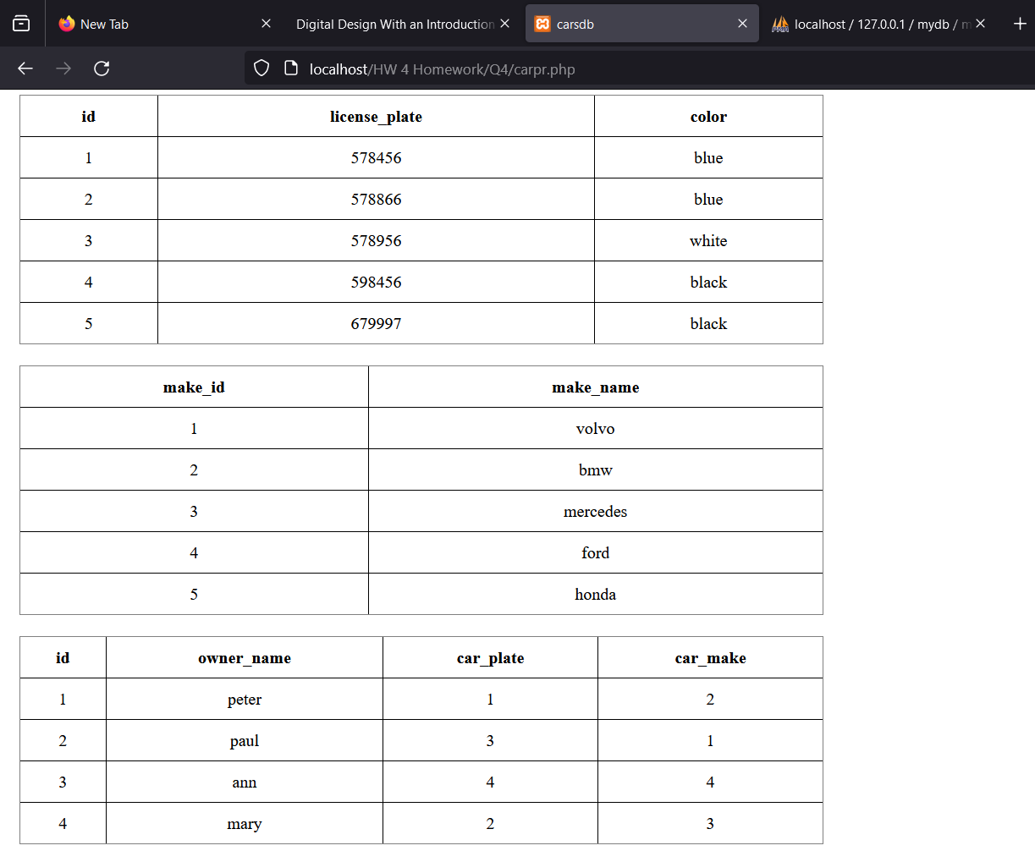

4c. find the names of the owners that have cars with their license plate and color

**CODE:**

<!-- PART 4: C cartest1.php -->

<!DOCTYPE HTML>

<html lang="en">

<head>

<meta charset="UTF-8">

<title>cartest1</title>

</head>

<body>

<?php

//header of the page

echo '<h1 align="center">Query 4C</h1>';

//connect to database

$dbc = @mysqli_connect('localhost', 'root', '', 'carsdb');

//make query

$query = 'SELECT owner.owner_name, car.license_plate, car.color FROM owner

JOIN car ON owner.car_plate = car.id';

//run query

$result = mysqli_query($dbc, $query);

//get the count of rows

$num = mysqli_num_rows($result);

if ($num > 0){

//create table header

echo '<table align="center" width="50%" border="solid" cellpadding="10">

<thead>

<tr align="center">

<th align="center">owner_name</th>

<th aligh="center">license_plate</th>

<th align=”center”>color</th>

</tr>

</thead>

<tbody>';

//shows all values in car table

while ($row = mysqli_fetch_assoc($result))

echo '<tr><td align="center">' . $row['owner_name'] . '</td>

<td align="center">' . $row['license_plate'] . '</td>

<td align="center">' . $row['color'] . '</td></tr>';

echo '</tbody></table>';

mysqli_free_result($result); //free up space

} elseif ($result) { //empty query result

echo "Query returned zero results";

mysqli_free_result($result); //free up space

} else { //error with query

echo "Error retrieving query result: " . mysqli_error($dbc);

}

mysqli_close($dbc)

?>

</body>

</html>

**OUTPUT:**

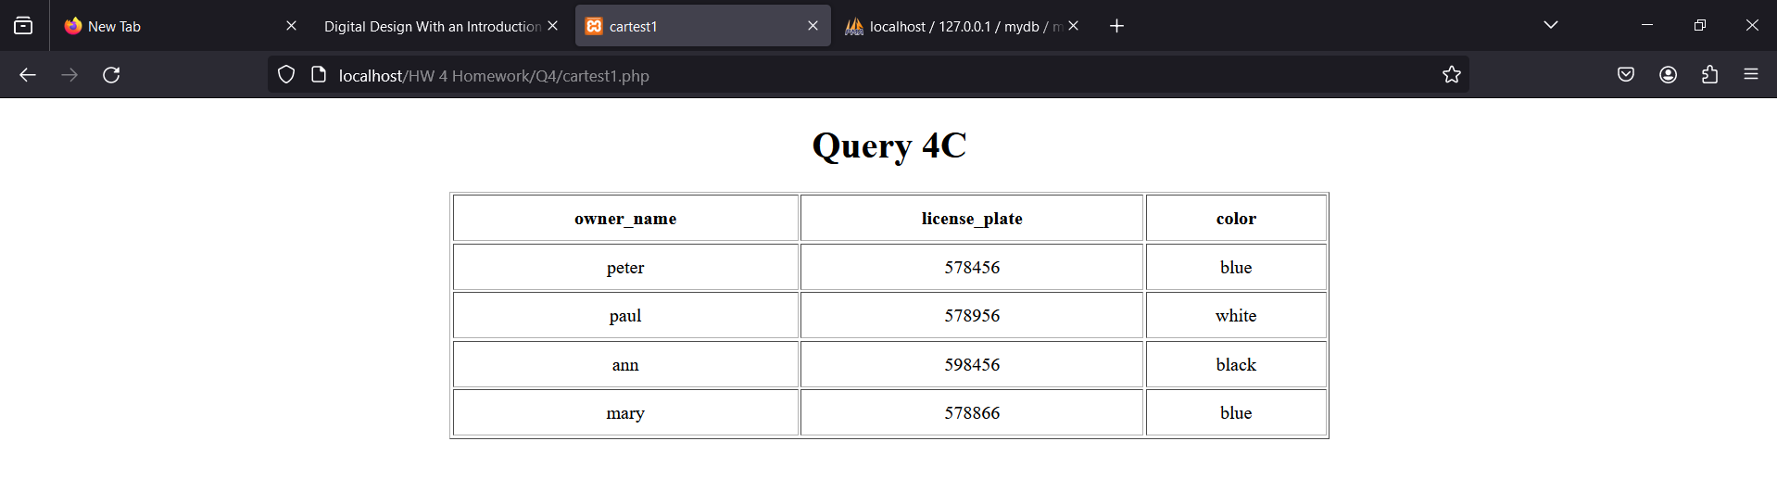

4d. find the names of the owners that have cars with their color and make (order by name).

**CODE:**

<!-- PART 4: D cartest2.php -->

<!DOCTYPE HTML>

<html lang="en">

<head>

<meta charset="UTF-8">

<title>cartest2</title>

</head>

<body>

<?php

//header of the page

echo '<h1 align="center">Query 4D</h1>';

//connect to database

$dbc = @mysqli_connect('localhost', 'root', '', 'carsdb');

//make query

$query = 'SELECT owner.owner_name, car.color, make.make_name FROM owner

JOIN make ON owner.car_make = make.make_id JOIN car ON owner.car_plate = car.id

ORDER BY owner.owner_name';

//run query

$result = mysqli_query($dbc, $query);

//get the count of rows

$num = mysqli_num_rows($result);

if ($num > 0){

//create table header

echo '<table align="center" width="50%" border="solid" cellpadding="10">

<thead>

<tr align="center">

<th align="center">owner_name</th>

<th align=”center”>color</th>

<th align=”center”>make_name</th>

</tr>

</thead>

<tbody>';

//shows all values in car table

while ($row = mysqli_fetch_assoc($result))

echo '<tr><td align="center">' . $row['owner_name'] . '</td>

<td align="center">' . $row['color'] . '</td>

<td align="center">' . $row['make_name'] . '</td></tr>';

echo '</tbody></table>';

mysqli_free_result($result); //free up space

} elseif ($result) { //empty query result

echo "Query returned zero results";

mysqli_free_result($result); //free up space

} else { //error with query

echo "Error retrieving query result: " . mysqli_error($dbc);

}

mysqli_close($dbc)

?>

</body>

</html>

**OUTPUT:**

4e. find the make of cars that have not owners (you can use subquery)

**CODE:**

<!-- PART 4: E cartest3.php -->

<!DOCTYPE HTML>

<html lang="en">

<head>

<meta charset="UTF-8">

<title>cartest3</title>

</head>

<body>

<?php

//header of the page

echo '<h1 align="center">Query 4E</h1>';

//connect to database

$dbc = @mysqli_connect('localhost', 'root', '', 'carsdb');

//make query

$query = 'SELECT make_name FROM make WHERE make_id NOT IN (SELECT car_make FROM owner)';

//run query

$result = mysqli_query($dbc, $query);

//get the count of rows

$num = mysqli_num_rows($result);

if ($num > 0){

//create table header

echo '<table align="center" width="50%" border="solid" cellpadding="10">

<thead>

<tr align="center">

<th align="center">car makes without an owner</th>

</tr>

</thead>

<tbody>';

//shows all values in car table

while ($row = mysqli_fetch_assoc($result))

echo '<tr><td align="center">' . $row['make_name'] . '</td></tr>';

echo '</tbody></table>';

mysqli_free_result($result); //free up space

} elseif ($result) { //empty query result

echo "Query returned zero results";

mysqli_free_result($result); //free up space

} else { //error with query

echo "Error retrieving query result: " . mysqli_error($dbc);

}

mysqli_close($dbc)

?>

</body>

</html>

**OUTPUT:**

Hint: for a,b questions you can use a php script (carpr.php)

For each of the next questions (c,d,e) you can create separate scripts (cartest1,php,cartest2.php, cartest3.php).

Screenshots of the programs’ output for all the questions are needed.